GUIDE TO INFORMATION
Produced by:
West Granton Housing Co-operative

Available through the
OFFICE OF THE INFORMATION COMMISSIONER
SCOTLAND (OSIC)

MODEL PUBLICATION SCHEME 2018

Contents
Terms Used 4
About West Granton Housing Co-operative 5
Our Committee of Management (Board) 6
Organisation Structure 6
Introduction to West Granton Housing Co-operative 7
Guide to Information 7
The Model Publication Scheme Principles 8
Principle One: Availability and formats 9
Principle Two: Exempt information 9
Principle Four: Charges 10
Colour Photocopying 10
Alternative Formats 10
Postage Costs 11
Charges for information which is not available under the scheme: 11
→ General information requests 11
→ Charges for Environmental Information 11
→ Charge for request for your own personal data 12
Principle 5: Advice and Assistance 12
Contact Details 12
Principle 6: Duration 13
Records Management Policy 13
Classes of Information 13
The classes of information that we publish 13
Class 1 14
About Our Organisation 14
Class 2 15
How We Deliver Our Functions and Services 15
Class 3 17
How We Take Decisions and What We Have Decided 17
Class 4 17
What We Spend And How We Spend It 17
Class 5 18
How We Manage Our Human, Physical and Information Resources 18
Class 6 20
How We Procure Goods and Services from External Providers 20
Class 7 20
How We Are Performing 20
Class 8 21
Our Commercial Publications 21
Class 9 21
Our Open Data 21

Terms Used

Term Used | Explanation
FOISA | The Freedom Of Information (Scotland) Act 2002
EIRs | The Environmental Information (Scotland) Regulations 2004
Model Publication Scheme | A standard framework for authorities to publish information under FOISA approved by the Scottish Information Commissioner
MPS | The Model Publication Scheme
Guide to Information | A guide that every public authority adopting the MPS must produce to help people access the information it makes available
MPS Principles | The six key principles with which all information published under the MPS must comply
Classes of Information | Nine broad categories describing the types of information authorities must publish (if they hold it)

About West Granton Housing Co-operative
West Granton Housing Co-operative Limited (WGHC) was formed in 1990 by residents of the West Granton area of north Edinburgh to provide new rented housing in an area dominated by low demand council housing.
Initially deck access blocks in West Granton itself were demolished and a phased redevelopment of the area took place. We now own 372 properties and two play park areas. We are community based with all our stock based in North Edinburgh between the Forthquarter development at the Waterfront, Granton and Ferry Road Avenue.
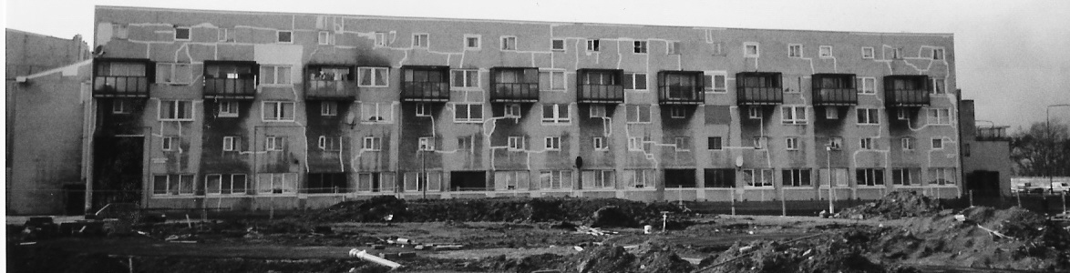

Before WGHC: Deck access flats in West Granton prior to demolition in 1993.
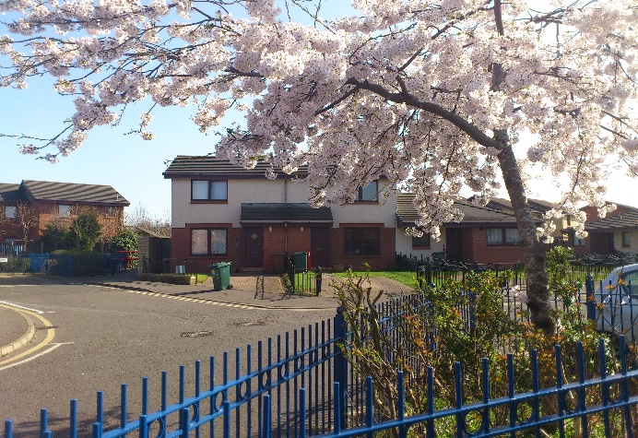
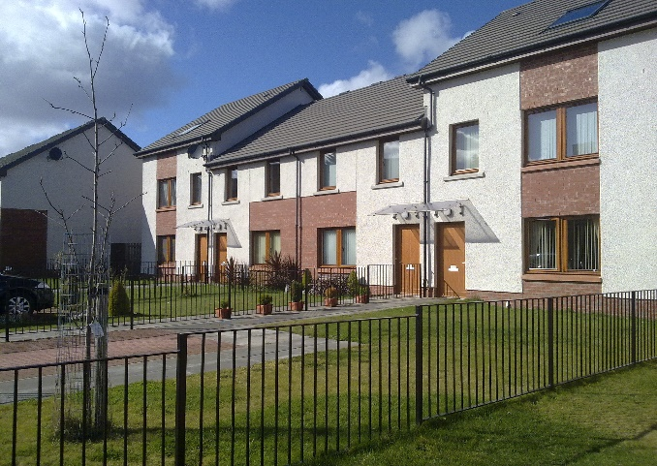
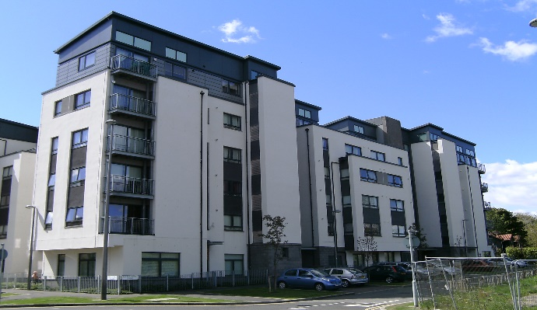

After: our current stock: Granton Mill Drive (top left) Forthquarter (top right) Ferry Road Avenue (bottom left) and Granton Mains Avenue (bottom right).

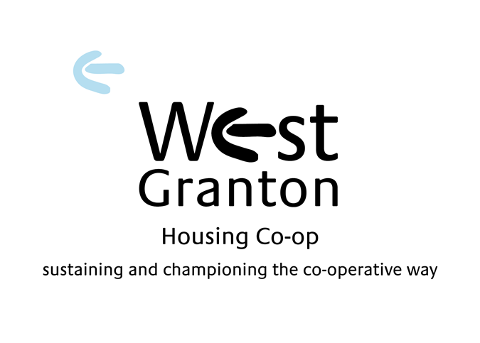

Our Mission Statement
Sustaining and championing the co-operative way

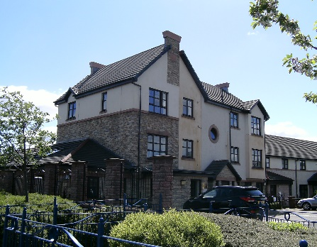
Our Values
- Our Tenants are paramount in everything we do
- We aim to provide safe, secure, affordable homes
- We believe there is strength in community and will look to support this where we can
- We strive for sustainability and strength for the future

Our Committee of Management (Board)
Our Committee of Management (Board of Directors) provide the strategic direction for West Granton Housing Co-operative and ensures that we try to attain and maintain the highest level of standards and performance. They meet at least ten times per year.
The Committee consists of 10 fully elected members.
West Granton Housing Co-operative’s Committee is made up entirely of tenants as the Co-operative is a tenant led organisation. Under its constitution, only tenants can be members, unless co-opted on to the Committee by agreement.

Organisation Structure
The Committee of Management have overall responsibility for the governance of the organisation and set the overall strategy for the business as well as monitor its activities. The CEO is charged with the task of implementing their decisions, along with the support of the Senior Management Team and staff. The West Granton Housing Co-operative staff structure is shown below:

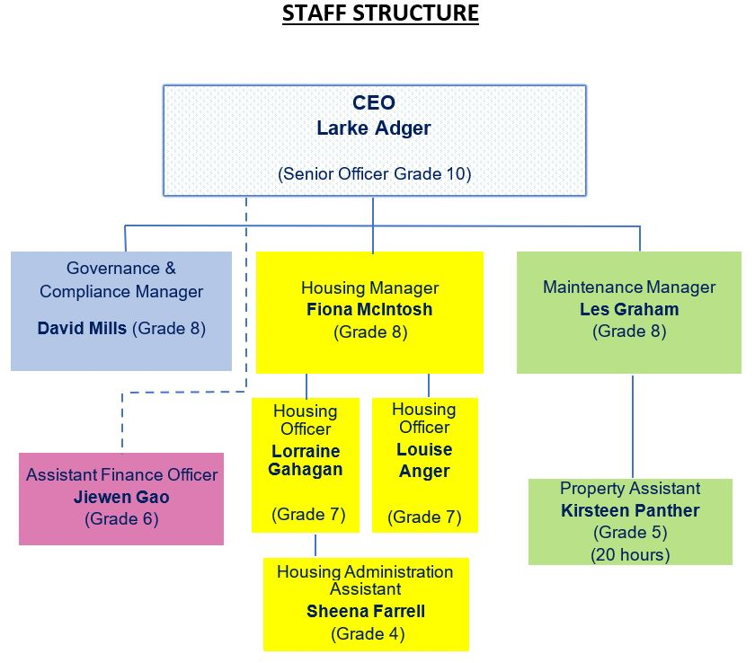

Introduction to West Granton Housing Co-operative

Guide to Information
The Freedom of Information (Scotland) Act 2002 (the Act) requires Scottish public authorities to adopt and maintain a publication scheme which has the approval of the Scottish Information Commissioner and publish information in accordance with that scheme. The publication scheme must:
- publish the classes of information that the authority makes routinely available
- tell the public how to access the information and whether information is available free of charge or on payment

West Granton Housing Co-operative has been designated as a Scottish Public Authority by an order made under section 5 of the Act, known as the Freedom of Information (Scotland) Act 2002 (Designation of Persons as Scottish Public Authorities) Order 2013.
The MPS is a standard framework for Scottish public authorities to publish the information they hold.
West Granton Housing Co-operative has adopted the:
Model Publication Scheme 2018
which has been produced and approved by the Scottish Information Commissioner.

You can see this scheme on our website at: Click here to access or by contacting us at the address in the Contact Us section if you prefer a copy to be provided to you in another format.
It is also available on the Scottish Information Commissioner’s website. Click here to access.
The purpose of the Guide to Information is to:
- allow the public to see what information is available (and what is not available) for West Granton Housing Co-operative in relation to each class in the Model Publication Scheme 2018
- state what charges may be applied
- explain how to find the information easily
- provide contact details for enquiries and to get help with access to the information
- explain how to request information that has not been published.

Alongside the Act, the Environmental Information (Scotland) Regulations 2004 (the EIRs) provide a separate right of access to the environmental information that we hold. This guide to information also contains details of the environmental information that we routinely make available.

The Model Publication Scheme Principles

The Model Publication Scheme imposes six principles which govern the way we must make our information available through our Guide to Information:
- Principle 1: Availability and formats
- Principle 2: Exempt information
- Principle 3: Copyright and re-use
- Principle 4: Charges
- Principle 5: Advice and assistance
- Principle 6: Duration

Principle One: Availability and formats
The information published through the Model Publication Scheme is, wherever possible, available on our website. In the Classes of Information section, select the class required.
We offer alternative arrangements for people who do not want to, or cannot, access the information online or by inspection at our premises. For example, we can usually arrange to send information to you in paper copy (although there may be a charge for this – see “Principle 4: Charges”).

Principle Two: Exempt information
We will publish all the information we hold that falls within the classes of information. If a document contains information that is exempt under Scotland’s freedom of information laws (for example sensitive personal information or a trade secret), we will remove or redact (black out) the information before publication and explain why.

Principle Three: Copyright and re-use
Where West Granton Housing Co-operative holds the copyright in its published information, the information may be copied or reproduced without formal permission, provided that:
- It is copied or reproduced accurately
- It is not used in a misleading context, and
- The source of the material is identified

Where West Granton Housing Co-operative does not hold copyright in information we publish, we will make this clear.

Principle Four: Charges
This section explains when we may make a charge for our publications and how any charge will be calculated. There is no charge to view information on our website or at our premises.
We may charge for providing information to you, but we will charge you no more than it costs us to do so.
We will always tell you what the cost is before providing the information to you.
Our photocopying charge per side of paper is shown in the tables below:

Our photocopying charge per side of paper is shown in the tables below:

Black & White Photocopying

Size of Paper |  | Pence per sheet
 | A4 | 15p
 | A3 | 25p

Colour Photocopying

Size of Paper | Pence per sheet
A4 | 25p
A3 | 40p

Alternative Formats

Format | Charge
Computer Discs | £1.00 per CD-ROM
Memory Stick | £8.00 per Memory Stick

Postage Costs
Postage costs may be recharged at the rate we paid to send the information to you. Our charge is for sending information by Royal Mail First Class.
When providing copies of pre-printed publications, we will charge no more than the cost per copy of the total print run.
We do not pass on any other costs to you in relation to our published information.

Charges for information which is not available under the scheme:
If you submit a request to us for information which is not available in this Guide the charges will be based on the following calculations:

General information requests
- There will be no charge for information requests which cost us £100 or less to process
- Where information costs between £100 and £600 to provide you may be asked to pay 10% of the cost. That is, if you were to ask for information that cost us £600 to provide, you would be asked to pay £50 calculated on the basis of a waiver for the first £100 and 10% of the remaining £500
- We are not obliged to respond to requests which will cost us over £600 to process
- In calculating any fee, staff time will be calculated at actual cost per staff member hourly salary rate to a maximum of £15 per person per hour
- We do not charge for the time to determine whether we hold the information requested, nor for the time it takes to decide whether the information can be released. Charges may be made for locating, retrieving and providing information to you
- In the event that we decide to impose a charge we will issue you with notification of the charge (a fees notice) and how it has been calculated. You will have three months from the date of issue of the fees notice in which to decide whether to pay the charge. The information will be provided to you on payment of the charge. If you decide not to proceed with the request there will be no charge to you.

Charges for Environmental Information
Environmental information is provided under the EIRs rather than FOISA. The rules for charging for environmental information are slightly different.
We do not charge for the time to determine whether we hold the environmental information requested or deciding whether the information can be released. Charges may be made for locating, retrieving and providing information to you e.g. photocopying and postage. If we decide to impose a charge, we will issue you with notification of the charge and how it has been calculated. The information will be provided to you on payment of the charge. If you decide not to proceed with the request there will be no charge to you. Charges are calculated based on the actual cost to West Granton Housing Co-operative of providing the information.

- Photocopying is charged at 15p per A4 sheet for black and white copying, 25p per A4 sheet for colour copying.
- Postage is charged at actual rate for Royal Mail First Class.
- Staff time is calculated at actual cost per staff member hourly salary rate to a maximum of £15 per person per hour.

The first £100 worth of information will be provided to you without charge. Where information costs between £100 and £600 to provide, you will be asked to pay 10% of the cost. That is, if you were to ask for information that cost us £600 to provide, you would be asked to pay £50, calculated on the basis of a waiver for the first £100 and 10% of the remaining £500. Where it would cost more than £600 to provide the information to you, however, we will ask you to pay the full cost of providing the information, with no waiver for any portion of the cost. If you wish to make an Environmental Information Request using our online form click here.

Charge for request for your own personal data
There is usually no charge* for requesting your own personal data under the General Data Protection Regulation (GDPR) Subject Access Request.
If you wish to make a Subject Access Request using our online form click here.
We must provide a copy of the information free of charge. *However, we can charge a ‘reasonable fee’ when a request is manifestly unfounded or excessive, particularly if it is repetitive. We may also charge a reasonable fee to comply with requests for further copies of the same information. This does not mean that we can charge for all subsequent access requests. The fee must be based on the administrative cost of providing the information. Further information on GDPR can be found on the Information Commissioner’s Office website. Click here to access.

Principle 5: Advice and Assistance

Contact Details
You can contact us for assistance about any aspect of this publication scheme or help to find and request information:
West Granton Housing Co-operative
26 Granton Mill Crescent, Edinburgh
EH4 4UT

T: 0131 551 5035
E: mail@westgrantonhc.co.uk
We will also advise you how to ask for information that we do not publish or how to complain if you are dissatisfied with any aspect of the publication scheme. If you wish to make a request for information not contained in the publication scheme, you can complete our online FOI online request form by clicking here.

Principle 6: Duration
Once published through the Guide to Information, information will be available for the current and previous two financial years.
Where information has been updated or superseded, only the current version will be available (previous versions may be requested from West Granton Housing Co-operative under section 1(1) of FOISA).

Records Management Policy
West Granton Housing Co-operative regards its records as a major asset of the Company. It confirms that its records are one of the essential resources which support management in the efficient and effective fulfilment of its governance, business and legal responsibilities. West Granton Housing Co-operative Records Management Policy can be found in Classes of Information - Class 5.

Classes of Information

The classes of information that we publish
We publish all the information that we hold within the following classes. Once information is published under a class we will continue to make it available for the current and previous two financial years.
Where information has been updated or superseded, only the current version will be available. If you would like to see previous versions, you may make a request to us for that information.

The classes are:
Class 1: About West Granton Housing Co-operative
Class 2: How we deliver our functions and services
Class 3: How we take decisions and what we have decided
Class 4: What we spend and how we spend it
Class 5: How we manage our human, physical and information resources
Class 6: How we procure goods and services from external providers
Class 7: How we are performing
Class 8: Our commercial publications
Class 9: Our open data

Class 1

About Our Organisation
West Granton Housing Co-operative

Information about West Granton Housing Co-operative, who we are, where to find us, how to contact us, how we are managed and our external relations.

The information we publish under Class 1: | How to access it
Our Committee of Management | Online; The Committee of Management
Our Staff Structure | Online; Staff
Contact Details | Online; Contact Us
News | Online; Home Page of Website
Model Publication Scheme 2018 | Online; Publications Page
Rules of the Co-operative | Online; Publications Page
How to make a request for personal information | Online; Contact Us
How to make a freedom of information request | Online; Contact us
How to complain or make a comment | Online; Contact Us
Guide to Information | Online; Publications Page
West Granton Housing Co-operative Information Charging Guide | Guide to Information; Charges Page
Annual Report & Financial statement | Online; Publications Page

Class 2

How We Deliver Our Functions and Services
Information about our work, our strategy and policies for delivering functions and services and information for our service users.

The information we publish under Class 2: | How to access it
How to report a repair | Online; Contact Us
Right to Repair information | Online; Publications Page
How to apply for a house | Online; What do you want to do
How to make a complaint | Online; Contact us
How to speak to a housing officer | Online; Contact us
Allocations Policy | Online; Publications Page
Appropriate Language Use Policy | Online; Publications Page
Code of Conduct for Governing Body Members | Online; Publications Page
Complaints Handling Policy | Online; Publications Page
Data Breach Notification Policy | Online; Publications Page
Data Protection Policy | Online; Publications Page
Data Retention Policy | Online; Publications Page
Data Subject Access Request Policy | Online; Publications Page
Debt Management Policy | Online; Publications Page
Environmental Information Regulations Policy | Online; Publications Page
Equalities & Diversity Policy | Online; Publications Page
Financial Regulations | Online; Publications Page
Freedom of Information Policy | Online; Publications Page
Governance Policy | Online; Publications Page
Health and Safety Policy | Online; Publications Page
Induction for New Committee Members | Online; Publications Page
Information Policy | Online; Publications Page
Maintenance Policy | Online; Publications Page
Procurement Strategy | Online; Publications Page
Rent Setting Policy | Online; Publications Page
Settlement Agreements Policy | Online; Publications Page
Tenant Allocations Consultation report | Online; Publications Page
Tenancy Management Policy | Online; Publications Page
Tenant Participation Strategy | Online; Publications Page
Unacceptable Actions Policy | Online; Publications Page

Class 3

How We Take Decisions and What We Have Decided
Information about the decisions we take how we make decisions and how we involve others.

The information we publish under Class 3: | How to access it
Public Consultations | Online; Publications Page
Board Agendas and Reports | Online; Publications Page
Approved Board Reports | Online; Publications Page
Approved Board Minutes | Online; Minutes of Committee

Class 4

What We Spend And How We Spend It
Information about our strategy for, and management of, financial resources (in sufficient detail to explain how we plan to spend public money and what has actually been spent).

The information we publish under Class 4 includes: | How to access it
Senior Staff/Board Member expenses | On Request
Pension Arrangements | On Request
Pay & Grading Structure | On Request
Financial management and administration policies and procedures | On request
Annual Report & financial statements | Online; Publications Page
Audited Accounts | Online; Publications Page

Class 5

How We Manage Our Human, Physical and Information Resources
Information about how we manage the human, physical and information resources of the authority.

The information we publish under Class 5 includes: | How to access it
Adoption, Maternity, Paternity and Shared Parental Leave | On Request
Alcohol Drugs & Substance Abuse | On Request
Attendance Management | On Request
Conflict of Interest | On Request
Disciplinary and Grievance | On Request
Equal Opportunities | On Request
Flexible Working | On Request
Information Communication & Technology | On Request
Leave of Absence | On Request
Lone Working | On Request
Salary Structure | On Request
Pension Regulations | On Request
Recruitment & Selection | On Request
Redundancy | On Request
Resolution of Difference Policy | On Request
Respect Policy | On Request
Retirement and Pension Policy | On Request
Smoking | On Request
Stress | On Request
Time Off for Union Duties & Activities Policy | On Request
Travel & Expenses | On Request
Vehicle and Driving | On Request
Whistleblowing | On Request
Retention Schedule | On Request
Freedom of Information Procedures | On Request
Water Quality | On Request
Environmental Reports | On Request
Recycling | On Request
Agreement with Trade Unions | On Request

Class 6

How We Procure Goods and Services from External Providers
Information about how we procure goods and services, and our contracts with external providers.

The information we publish under Class 6 includes: | How to access it
Procurement Strategy | Online; Publications Page
Procurement Procedures  Incorporated in Maintenance Policy & Financial Regulations | Online; Publications Page
Becoming an Approved Contractor or Consultant  Maintenance Policy Page 30 | Online; Publications Page

Class 7

How We Are Performing
Information about how we perform as an organisation, and how well we deliver our functions and services.

The information we publish under Class 7 includes: | How to access it
Annual Report | Online; Publications Page
ARC Landlord Report to Tenants | Online; Publications Page
Performance Standards/indicators | On request
Benchmarking information | On request
Complaints policy and Guidance | Online; Publications Page
Complaints Form | Online; Contact Us
Complaints reports or equivalent to show how complaints are handled and influence service delivery (aggregate reports rather than individual outcomes). | Summary Report  Online in Newsletter  Full report on Request

Class 8

Our Commercial Publications
Information packaged and made available for sale on a commercial basis and sold at market value through a retail outlet e.g. bookshop, museum or research journal.

The information we publish under Class 8 includes: | How to access it
West Granton Housing Co-operative does not hold or publish any information under this class. | N/A

Class 9

Our Open Data
Open data made available by the authority as described by the Scottish Government’s Open Data Resource Pack and available under an open licence.

The information we publish under Class 9 includes: | How to access it
West Granton Housing Co-operative does not hold or publish any information under this class. | N/A

